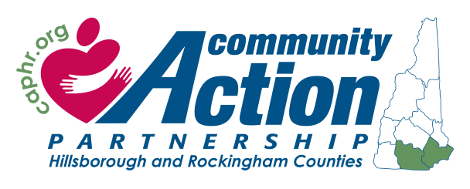
Class Location & Time:
Retired and Senior Volunteer Program (RSVP)
BONE BUILDERS EXERCISE PROGRAM
MEDICAL RELEASE STATEMENT FOR EXERCISE

PARTICIPANT/PATIENT INFORMATION
Please fill in this information prior to giving the form to your medical provider
Name
Address
Phone Number
Where did you hear about the program?
CLASS LOCATION

Your patient would like to participate in an on-going osteoporosis prevention exercise program. The RSVP BONE BUILDERS Program is based on a program originally developed at Tufts University. Research published in the New England Journal of Medicine and JAMA have demonstrated conclusively that weight training and balance exercises give participants the strength and stability to significantly reduce incidents of falling and fracturing bones.
Your patient needs your medical clearance in order to join a class. Your patient can provide you with more detailed information about the program if desired. You can also contact us at
(603) 598-9421.
This form can be faxed to the Manchester RSVP office at (603) 641-6054 and/or our Nashua RSVP office at (603) 459-8157

My patient has no current medical problems that prevent his/her participation in RSVP BONE BUILDERS progressive weight and balance training program.

TO BE COMPLETED BY THE PHYSICIAN
Physician’s Name
Address |  | Phone
Physician’s Signature |  | Date

Community Action Partnership Hillsborough and Rockingham Counties – www.caphr.org
145 Ledge Street, Nashua, NH 03060 (603) 598-9421 Revised 2/3/25 08/2019
1

